In class “Candy Question” Jan 29th, 2013 (ECE 322)

Note: Please solve this as a part of your team. The first team to correctly solve this on the board will get candies!

DC Analysis of a 2 Stage Cascade Amplifier
Consider the 2 stage amplifier cascade amplifier shown below. Assuming that the transistor parameters are V_{TN}=1.2V and λ=0 for both transistors, K_{n1}=500μA/V², K_{n2}=200μA/V², R₁||R₂= 200KΩ. Not that V⁺=5V and V⁻=-5V. Design the circuit such that I_{DQ1} = 0.1 mA, I_{DQ2} = 0.3 mA and V_{DSQ1}= V_{DSQ2}= 5V.
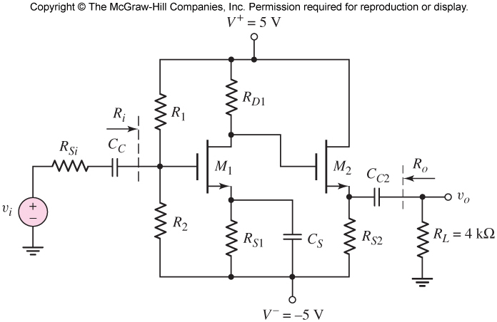
Note: Designing the circuit means finding out all the values of the resistors (R_{S2}, R_{S1}, R_{D1,} R₁ and R_{2.}

SOLUTION
